FORM D
PARTICULARS OF AN APPLICANT WHO HAS
LOST/DAMAGED THE PASSPORT

HC Ref : ……………………………. HO Ref : …………………………….

- Surname: ……………………………………………………………………………………………………………………
- Other Names: …………………………………………………………………………………………………………….
- Maiden Name : …………………………………………………………………………………………………………..
- Date of Birth : ……………………………………… 05. Place of Birth ……………………………………….
- Country of Birth : ………………………………… 07. NIC No: ………………………………………………..
08 Sex : ……………………………………………………. 09. Civil Status : ………………………………………..
10. Passport No : …………………. Date of Issue : …………………… Date of Expiry …………………..
11. Height (cm) : ………………….. 12. Colour of Eyes : …………………………………………………………
13. Distinguishing Mark : …………………………………………………………………………………………………
14. Father’s Name : ………………………………………………………………………………………………………..
Place of Birth : ……………………………………….. Nationality …………………………………………….
15. Mother’s Name : ……………………………………………………………………………………………………….
Place of Birth : ……………………………………….. Nationality …………………………………………….
16. Name & Address of spouse : …………………………………………………………………………………….
………………………………………………………………………………………………………………………………….
17. Names & Age of Children :
Name Age
i…………………………………………………………………… ………………………………………………….
ii …………………………………………………………………. ………………………………………………….
iii ………………………………………………………………… ………………………………………………….
Cont’d….2/-
- 02 –

18. Last known address in the UK : ………………………………………………………………………………………….
…………………………………………………………………………………………………………………………………………
19. Last known address in Sri Lanka : ………………………………………………………………………………………
………………………………………………………………………………………………………………………………………….
20. Date of leaving Sri Lanka for the first time : ……………………………………………………………………..
21. Means of Leaving : ……………………………………………………………………………………………………………
22. Date of arrival in UK : …………………………… 23. Means of Entry ………………………………………
24. Name & Address of a person in Sri Lanka who could give information regarding you :
…………………………………………………………………………………………………………………………………………
…………………………………………………………………………………………………………………………………........
25. Parent’s Address : …………………………………………………………………………………………………………..
Telephone No : ………………………………………..
26. Brother’s Name : ………………………………………………………………………………………………………………
Place of Birth : …………………………………. Address : ……………………………………………………………
Nationality : …………………………………….. Telephone No : ……………………………………………………
27. Sister’s Name : …………………………………………………………………………………………………………………
Place of Birth : …………………………………. Address : ……………………………………………………………
Nationality : …………………………………….. Telephone No : ……………………………………………………
28. Previous Employment : …………………………………………………………………………………………………….
29. Name & Address of last employer in Sri Lanka : …………………………………………………………………
…………………………………………………………………………………………………………………………………………

Cont’d…3/-

- 03 -
30. Present Employment : ……………………………………………………………………………………………………
31. Name & Address of present employer : …………………………………………………………………………….
………………………………………………………………………………………………………………………………………..
32. Schools attended in Sri Lanka :
School Date of Started Date of Leaving
i…………………………………………………… …………………………… …………………………………….
ii …………………………………………………. ………………………….. …………………………………….
33. Name & Address of Family Doctor in Sri Lanka : …………………………………………………………………
…………………………………………………………………………………………………………………………………………
34. Current Visa Status : …………………………………………………………………………………………………………
35. Give briefly the circumstances under which the Passport was lost :
………………………………………………………………………………………………………………………………………
……………………. …………………………………………………………………………………………………………………
36. Have you reported to the Police regarding loss of your Passport : ……………………………………..
If so :
When : ………………………………… Where : ………………………………………………………………………….

37. Do you hold any other Travel Documents : ……………………………………………………………………….

38. Have you applied for/obtained any other nationality : ………………………………………………………

39. Name & Address of your Grama Seva Niladhari : ……………………………………………………………….
…………………………………………………………………………………………………………………………………………
40. Address of local Police Station (Sri Lanka) :
………………………………………………………………………………………………………………………………………
Cont’d………4/-
- 04 –
41. Name & Address of your local Municipality / Pradeshiya Saba area :
………………………………………………………………………………………………………………………………………
42. Any other details : …………………………………………………………………………………………………………
…………………………………………………………………………………………………………………………………………
…………………………………………………………………………………………………………………………………………

I declare that the above details are fully understood and to the best of my knowledge are true and correct.

……………………………………… .…………………………………………………
Date Signature

Signed in the presence of :

Date : Signature of the Officer
Name : …………………………………………………
Designation : …………………………………………
Institution : …………………………………………

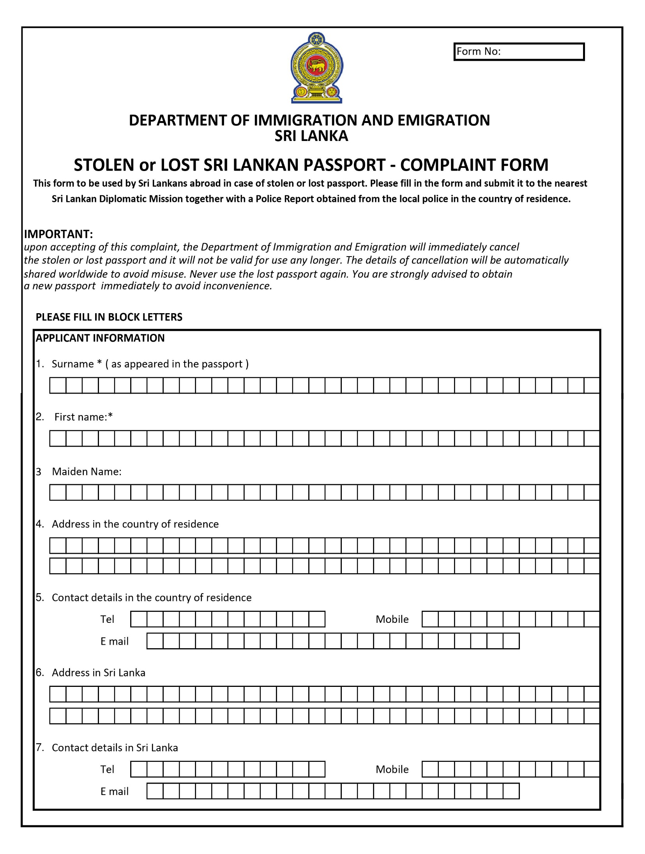
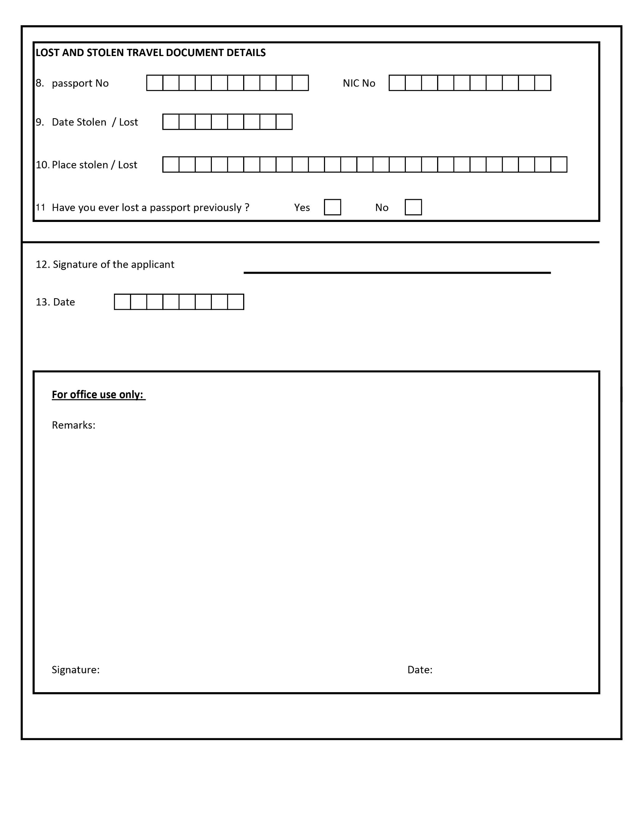
STATUTORY DECLARATION

I, ………………………………………………………………………………………………
of………………………………………………………………………………………………...
do hereby solemnly and sincerely declare as follows:

- I am a citizen of Sri Lanka and holder of Sri Lanka Passport No …………………….
Issued at …………………………………… on …………………………….

- I have not acquired voluntarily or through the operation of Law, the nationality of any other foreign country, nor have applied for such foreign nationality.

- I have not travelled out of United Kingdom since my passport expired/lost/damaged

I MAKE THIS SOLEMN DECLARATION CONSCIENTIOUSLY BELIEVING THE SAME TO BE TRUE, AND BY VIRTUE OF THE PROVISIONS OF THE STATUTORY DECLARATION ACT 1935

………………………………………………
Signature of Declarant

Declared at …………………………………
This ……………………. day of ……………………… 20….

Solicitor’s name & address
……………………………………….. …………………………
……………………………………….. Before me
………………………………………..
……………………………………….. (Signature of Solicitor)

